**A SMART AGRICULTURE APPLICATION DEVELOPMENT FOR MONITORING THE FIELDS USING IOT AND AI**

**Problem Statement:**

Agriculture is one of the world’s oldest occupation which is continued still now. The world’s population in one form or another is dependent on agriculture for their needs. The major loss in agriculture is due to the pests, plant disease, malnutrition and nutrient deficiency in plants. In order to identify these diseases, farmers go to the local farmers, experts,agricultural people, and fellow neighbors to identify the problem caused.In some cases, the information provided by them can be effective but in some cases, it is not.Not every problem caused by their crops can be solved by these people,there arises a need to accurately predict the correct disease and offer the right treatment at the right time. This can be only done by applying IoT solutions in real-time to solve the problem.A smart agriculture system is created to rectify the needs of the farmers by applying smart solutions by means of digital technology.

**Proposed Architecture:**

The proposed architecture comprises of three parts:

1. **Problem Identification in crops**
2. **Deep learning for accurate prediction of the problem**
3. **Smart Solutions for Smart Agriculture using IoT**
4. **MODULE I: Problem Identification in crops**

Farmers cannot keep an eye on everything that happens on the farm and provides rapid solutions.These can be done only by implementing digital technologies in the field to monitor what's happening and what are the problems that need to be identified early to provide immediate solutions to help the farmers increase their productivity, reduce employment costs and improve crop cultivation.

**Agricultural Sensors Used:**

The following sensors are used in the agricultural field to monitor the field in realtime and identify the problems.

1. **Agricultural Drones:**Drones are also known as Unmanned Aerial Vehicles(UAV’S) to monitor the growth of crops and increase the yield by means of using inbuilt sensors and imaging technology.The bird's eye point of view from the cameras help the farmers to view their farm from the sky and showcases critical issues such as pests,leaf diseases in crops,soil variation, irrigation problem, etc.The agricultural drones capture the multispectral images which posses two views
   * Near-Infrared View
   * Visual Spectrum View

Both views combined can help the farmers to differentiate between healthy and unhealthy crops. By periodically monitoring the farm the crop changes are noticed and any critical condition is identified at the first, and treatment is provided by rapid diagnosis.The agricultural drones manufactured have advanced processors,modern sensor technology and a real-time operating system to enhance the farming experience. The drones can carry herbicides and pesticides up to 25kg and apply it to places where necessary.

1. **Smartphones**

Smartphones are considered a popular tool in agriculture because nowadays every farmer has access to a smartphone.A smartphone has a wide range of built-in sensors ranging from GPS sensors,motion sensors, high-resolution HD cameras and many more.These smart sensors used in agriculture helps to identify the diseases and damages that occur in the farmers' crop.

1. **Satellite Farming**

Satellite farming helps to optimize the following in smart agriculture such as crop growth,fertilizer content in the soil, nutrient deficiency, pests and diseases in crops and to identify some crop failures at an early stage.It uses a remote sensing tool to analyze the satellite pictures captured to find whether the soil condition is suitable for crop cultivation or not. The remote sensing method used to identify troublesome areas is known as the Normalized Difference Vegetation Index (NDVI).NDVI identifies whether the crop condition is Good(Green) or Stressful(Damaged).The crop data can be analyzed periodically over time.Smart agriculture uses Satellite Imagery,Geographic Information System(GIS), and geospatial technologies in the field of agriculture.The satellite images obtained helps the farmers to characterize their field in detail by identifying the problematic areas with the help of GIS.GIS monitors and manages various aspects of the smart agricultural system.The geospatial technologies used help the farmers to identify the spatial variations in the food crops and soil conditions by means of analyzing the fertilizer content,water content and seed content.Too much fertilization content in the soil deteriorates the crop and increases the nitrogen content in the groundwater.There are two types of maps used in geospatial imaging that are:

* **Zone Maps:**The zone maps helps the farmers to identify the crops which are doing well and which are deteriorating by means of light signals generated in the electromagnetic spectrum.
* **Prescription Maps:**It shows the remedy needed for this area by means of providing the level of water,seed, and fertilizer to match the content.

1. **Electrochemical Sensors**

Electrochemical sensors are used to gather chemical-related content of the soil based on their ion content.The soil nutrient value and pH value are calculated using these sensors deployed. The electrochemical sensors used here is

* **ISFET(Ion Sensitive Field Effect Transistor)**
* **ISE(Ion Selective Electrodes)**

With the help of these potentiometric electrochemical sensors helps the farmers to identify the NPK(Nitrogen(N),Phosphorous(P) and Potassium(K)) level of the soil.Based on the NPK level, the fertilizer content is adjusted based on the soil needs.

**Problem Identification:**

With the help of the agricultural sensors used the following problems are identified

1. **Crop Issues:**

The crop issues are mainly due to the pest,weed,disease, and damage caused to the leaves.

* **Disease:** The disease can be caused due to the bacterias, viruses,and fungi affecting the crop both above and below the ground.The main challenge in smart farming is to control plant diseases to a great extent.The food crops which are consumed daily are mainly affected by crop diseases.The crop diseases are identified by the yellowing of margins,lesions and spot formation of any color.
* **Weed:** The weeds grow along with the agricultural crops, which makes it hard to distinguish both. It absorbs all the nutrients, water and the space allocated for the farmer’s food crops. These weeds are the second major challenge in the smart agriculture system which raises several issues such as attracting many pests,releasing toxic substances in the soil which worsens the plant’s growth to an extent that the farmer loses his Crop quality and yield which reduces the efficiency of the system.The identification of the weed is the first step to control it which helps to reduce the weed initially and prevent it by using the correct amount of herbicide.If the identified weed doesn’t cause any harm means, no action is initiated. The prediction of the weed plays a major role in the smart agricultural system.
* **Pest:**The problems by the pests in the crops are mainly caused by aphids, worms and any types of Insects.Pest damages the crops by eating the leaves and transmitting viral,fungal and bacterial growth to the crops. Not all kinds of pests can be considered as dangerous.Some are dangerous while others are not.
* **Damage:**The damage is identified by the amount of chlorophyll present in the leaves.If the leaves color changes from its original color to somewhat else,then the leaf is identified to be damaged.

**Crops In The Agricultural Field**

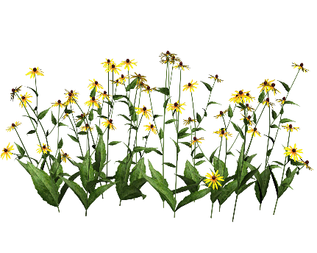

1. Agricultural Drones
2. Smartphones
3. Satelite Farming
4. Electochemical Sensors

**Field Monitoring In Realtime using sensors**

**Problem Identification**

1. **Crop Issues**

* Pest
* Weed
* Disease
* Damage

**2.Soil Issues**

* Fertilizer content analysis
* Nutrient Deficiency and Toxicity

**Figure 1:**Problem Identification in the agricultural field

1. **Soil Issues**

The soil issues are the next major issues in agriculture.Because the sustainability of the crops is mainly based on the nutrient content of the soil.If any changes happen in the soil,the changes can be reflected in the plants also.So the issues in soil need to be correctly identified in the initial stage itself.This research focuses on identifying two types of soil issues mainly

* **Fertilizer Content Analysis:**Knowing the exact fertilizer rate and ratio and accurate timing when the fertilizer needs to be applied plays an important role in Smart Agriculture.This is known as Fertilizer Content Analysis(FCA).FCA cannot be calculated in a single access,in order to identify the fertilizer content thousands of dynamic parameters have to be calculated to determine the accurate fertilizer rate of the soil.The FCA can be calculated by measuring the NPK level in the soil.If the fertilizer content in the soil increases to an extent, the growth of the crops will begin to degrade slowly.
* **Nutrient Deficiency and Toxicity:**Nutrient deficiency and toxicity in the soil lead to diseased crops.A plant is said to be nutrient deficient if the nutrients such as Phosphorous,Potassium,Sulphur,Zinc,Iron,Calcium,Magnesium, etc.If a plant is nutrient deficient it possesses the following symptoms:
  + **Stunting:**The crops growth is decreased to a great extent
  + **Necrosis:** This results in the death of the plant
  + **Inerveinal Chlorosis:** Yellowing in the green leaves
  + **Generalized: T**he symptoms are shown in the plant asthe whole
  + **Burning:** The leaves show a burning appearance

If the nutrients in the soil exceed the minimal amount it causes toxicity.Excess toxicity in the soil disrupts the ways in which the crops intake water and several other nutrients from the soil.

The WSN (Wireless Sensor Network) Deploymenthas appeared in Fig.2. The proposed system is used for the purpose of agriculture. The principal of the scheme is Raspberry pi. In this system,the WSN has been used. WSN consists of five different sensors; they are Temperature and humidity sensor, PIR sensor, Electrochemical sensor, Airflow sensor. At whatever point water won't siphon into the field because ofan adequate measure of water in the field. At whatever point, water will be siphoned into the field until the required measure of dampness is required then the water dampness level of the soil goes little. DHT11 sensor estimates the temperature and dampness estimation of the field. PIR movement sensor recognizes the movement of the intruderkeen onthe field. Electrochemical sensors help in social affair synthetic information of the specks of dirt by distinguishing explicit particles in the dirt. They give data's as pH and soil supplement levels. Wind stream sensors are utilized to gauge air porousness. They are utilized in a fixed position or in portable mode. In this manner, the sensor esteems are consistently checked and the readings are shown to the rancher's portable by means of GSM sim900A module is embedded into this modem which gives IoT highlights to the framework.

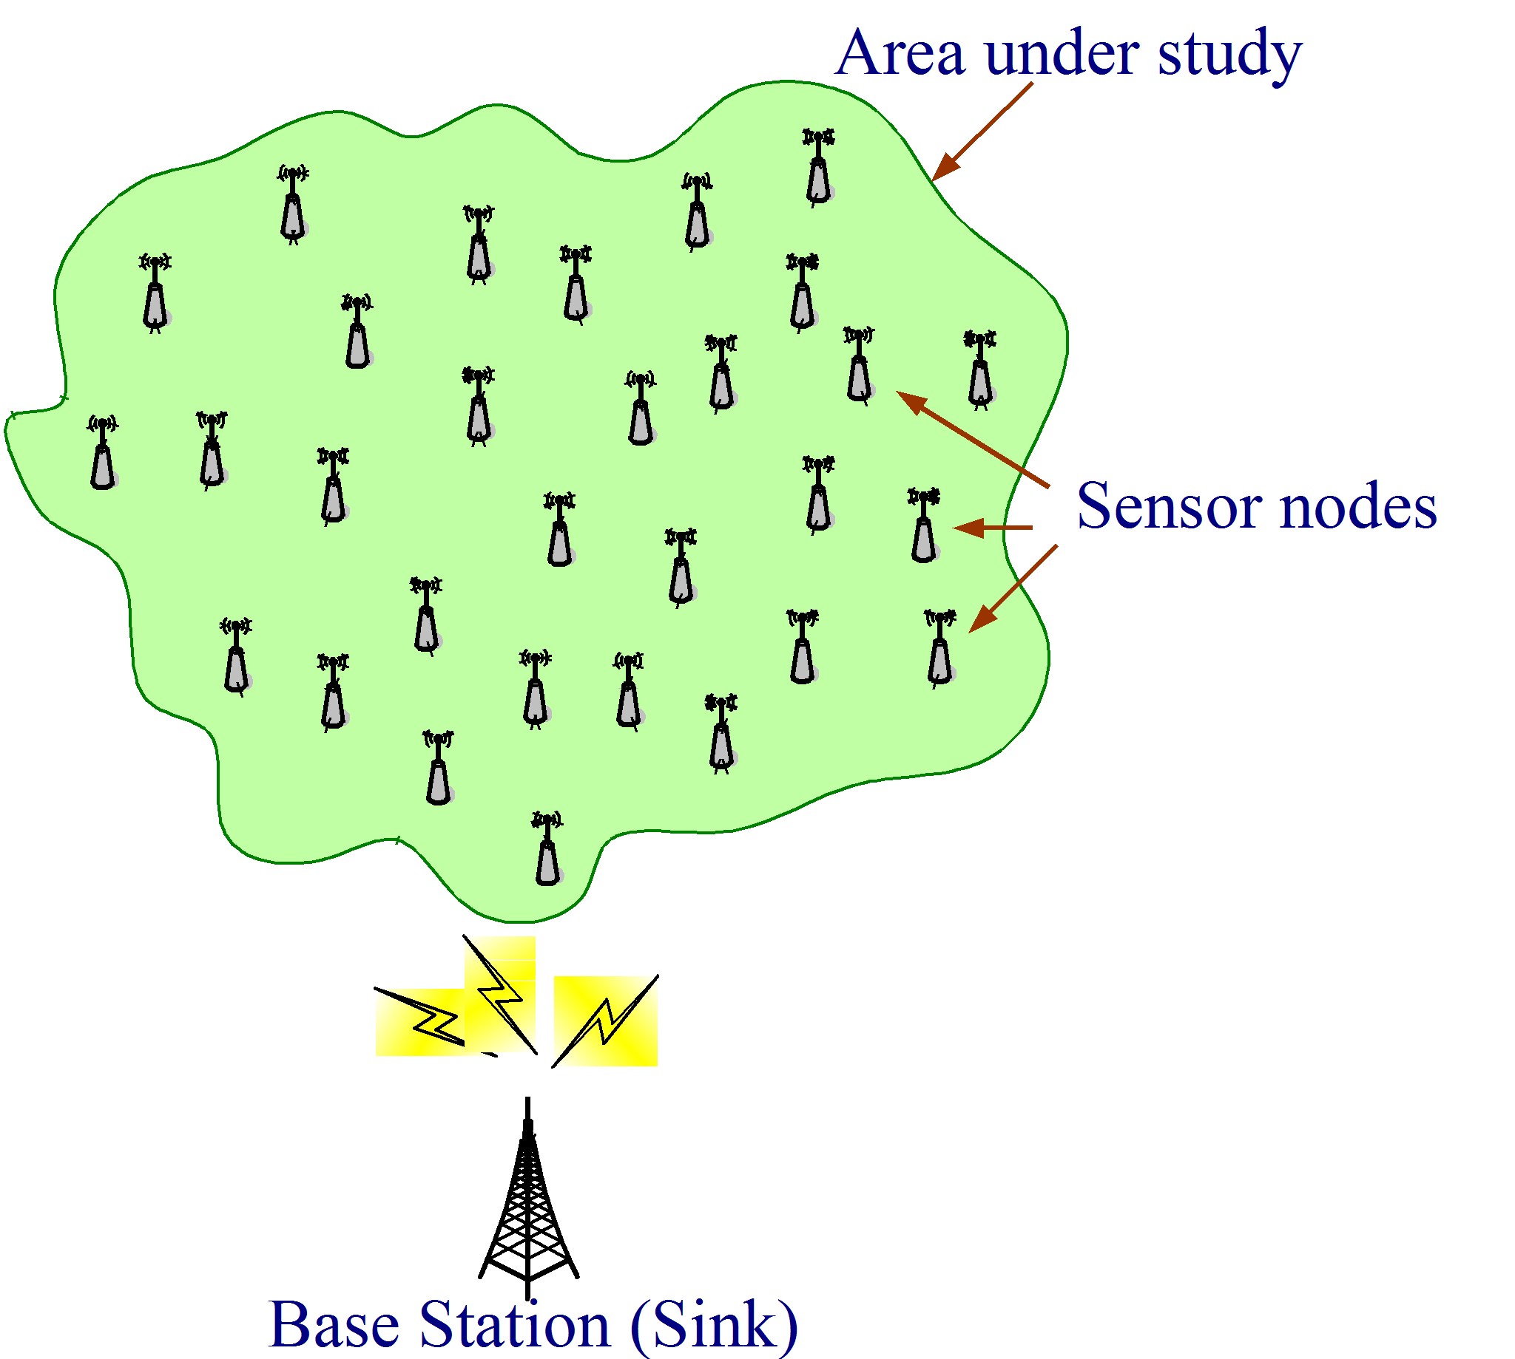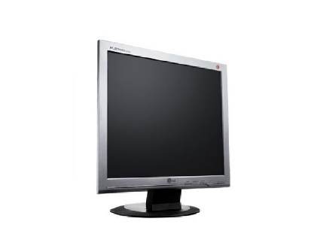

Raspberry pi

Power supply for mains and solar

WSN

GSM module



Mobile

Wi-Fi module

Relay node

Pump



Cloudplatform (IoT)

PC

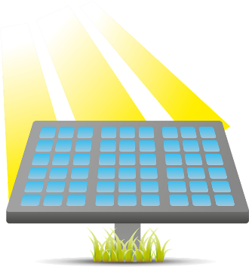

Main power supply

Solar plant

**Fig.2. WSN (Wireless Sensor Network) Deployment**

**GRNN (Generalized Regression Neural Network)in Smart Agriculture**

The GRNN (Generalized Regression Neural Network) in Smart Agriculturehas appeared in Fig.3. WSN capture the image for the problematic plants and the GRNN is used in agriculture for the purpose of prediction model which later compared the result obtained with multiple linear regression (MLR). The GRNN to identify the abnormal signal for some problems such as an increase in Fertilizing agents in soil, identify Diseased plants, increase or decrease of water level in soil or crops, etc. To identify any abnormal signal in agriculture plants, the system gives the alert message to the user’s mobile through IoT.

WSN (Wireless Sensor Network)

Identify any abnormal signal

GRNN predict any abnormal signal

* Increase in Fertilizing agents in soil
* Identify Diseased plants
* Increase or decrease of water level in soil/crops

o/p

**Fig.3. GRNN (Generalized Regression Neural Network) in Smart Agriculture**



User mobile

**Smart IoT application for Agriculture**

The Smart IoT application for Agricultureis shown in Fig.4. This proposed system the smart IoT app having two inputs and two outputs. The two inputs are capturing the images from the problematic plants in the GRNN system and the status of the WSN nodes in the WSN system. The smart IoT app to give the status of the agriculture plant such as the plants is decaying due to too much water retention etc. To detect the problems, they have used two methods. They are Blue River technology and Image-based insight generation. The blue river technology is a machine. The blue stream innovation is a machine. This machine utilizes PC vision and man-made consciousness to recognize, distinguish, and settle on the board choices about individual plants in the horticulture field with the goal that plants which are basic to ranchers and shoppers are not accidentally crushed by herbicides. The machine has mechanical spouts to guarantee precise showering of herbicides. The Image-based insight generation technology is used for the solution for the identified problem.

Device status:

Plantsare decaying due to too much water retention

Blue River technology

Image based insight generation

Input images from the problematic plants

Status of the WSN nodes

 Smart IoT app for agriculture

Based on image obtained and provide solution for the problem identified

Providing solution by self-correcting sensor nodes

I/p1

I/p2

Soln1

Soln2

**Fig.4. Smart IoT application for Agriculture**

1. **MODULE II: Deep learning for accurate prediction of the problem**

Deep learning derived from machine learning is a field of Artificial Intelligence that mimics the activities of human brain in processing the external data and taking decisions.A deep learning neural network gathers a lot of data obtained from the agricultural sensors deployed in the real-time environment which is unknown or unlabelled and gives accurate predictions on it. Deep learning can process big data information fastly and deliver precise results,in which the normal human takes a decade to solve the task.The deep learning model is formed by interconnected computing layers known as neural networks.The neural networks mimic the structure of the human brain,and each component in the neural network comprises of neurons and synapses.The deep learning model is trained by feeding the problem dataset captured by the IoT sensors.During the learning process the neural network identifies the features of the input and associates them with an accurate image label.The program is run until every feature in the unlabelled image input is identified and classified accurately.Each layer in the neural network trains various features to precisely detect the results in realtime with high speed.For example, the first layer computes the edges, discoloration and the next layer computes the colorchanges,this process goes on until the problem is correctly identified.Each layer obtains input from the previous layers and trains itself adjusting millions of different parameters without any manual intervention.These complex operations in the smart agricultural system cannot be performed without deep learning.This paper uses a deep convolutional neural network to identify the input images obtained from various sensors.

1. **Deep Convolutional Neural Network**

Deep Convolutional Neural Network(DCNN) identifies the input image precisely by the means of computer vision embedded with deep learning.DCNN takes an image as the input and assigns weights and biases to the various aspects included in the image which helps the system to differentiate one problem from another to identify each other uniquely.

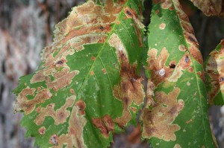

**Input Image**

**Identified Problem**

*ai,1*

**…….**

*ai,n*

**……**

***fi,1***

***fi,2***

**…..**

***fi,n***

…………………………………

Input Layer

Hidden Layer

Output

Layer

Activation Function

**Disease Name**

**Accuracy**

**Figure 5:**DCNN for accurate prediction of the problem

The above figure 5 describes the working of the DCNN in detail. The DCNN can identify any soil issues and the crop issues from the various images obtained from the sensors deployed in the agricultural fields.The accuracy of the results identified is also noted.The DCNN is programmed to identify the issues automatically. The identified crop issues and their accuracy rate are tabulated below from table I-IV.

**Crop Issues Identified by DCNN:**

**TABLE I:** PLANT DISEASES IDENTIFIED

|  |  |
| --- | --- |
| **Diseases of plants Identified** | **Accuracy(%)** |
| Yellow, Brown Rust | 98 |
| Leaf Blotch | 98 |
| Covered Smut | 99 |
| Powdery Mildew | 97.9 |
| Boron, Iron Deficiency | 98 |

**TABLE II:** LEAF DAMAGE IDENTIFIED

|  |  |  |
| --- | --- | --- |
| **Colour** | **Damage** | **Accuracy(%)** |
| Green | Undamaged | 98 |
| Not Green | Damaged | 98 |

**TABLE III:** WEEDS IDENTIFIED

|  |  |
| --- | --- |
| **Weeds Identified** | **Accuracy(%)** |
| Chickweed | 98 |
| Bindweed | 97 |
| Budda Pea | 98 |
| Black Pigweed | 98 |
| Strawberry Clover | 97 |

**TABLE IV:** PESTS IDENTIFIED

|  |  |
| --- | --- |
| **Pests Identified** | **Accuracy(%)** |
| Aphid | 98 |
| Spider Mite | 97 |
| Mealybug | 98 |
| Pollenbeatle | 98 |
| Cereal Leaf Beatle | 97 |

**Soil Issues Identified by DCNN:**

The soil issues identified by the DCNN is tabulated below in Table V and VI.

**TABLE V:** Fertilizer Content Analysis based on NPK level of soil

|  |  |
| --- | --- |
| **Fertilizer Content Analysis based on NPK level of soil** | **Accuracy(%)** |
| Low | Add fertilizer in the correct ratio for crop management |
| Medium | Add fertilizer in the correct ratio for crop management |
| High | Stop adding any fertilizers |
| Excess | Stop adding any fertilizers and take preventive methods |

**TABLE VI:Nutrient Deficient and Toxicity**

|  |  |  |
| --- | --- | --- |
| **NPK Values** | **Toxic** | **Nutrient Deficient** |
| **N** | >110 | <20 |
| **P** | >100 | <20 |
| **K** | >800 | 75-150 |

1. **MODULE III: Smart Solutions for Smart Agriculture using IoT**

DCNN accurately identifies the problem and sends the identified problem to the central controller to take preventive measures and provide solutions at the right time. The data collected from the previous module using DCNN helps the farmers to increase their yield and efficiency. Smart agriculture only applies herbicides and pesticides in the affected regions and saves costs to a huge extreme. The detection alone cannot save the problem.Biological treatments, chemical treatments, and cultural practices are necessary.So, the users can learn how to prevent damages in the next season.When the information is identified, the solution is provided to the farmers on spot.The central controller activates the preventive measures by remotely accessing the problems. The central controller is a PC powered by AI.Notification is the remainder to take corrective action at the right time by spraying.The spray timer processes all available data for your fields uses tried and tested models to closely monitor the risks of specific diseases.These following techniques are provided for smart solutions

1. Blue River Technology for weed management
2. Automatic Fertilizer Dosing Control

* Dilute Tanks
* Inline Injection

1. Spraying Fertilizers in the pest and disease affected zones by using agricultural drones

* Web Portal Acess for farmers
* Smartphone Application
* Scheduling Tasks
* Checking the fertilizer content of the soil
* Tracking of plant growth and identifying the pests,diseases and crop damages
* Weed Management

**CENTRAL CONTROLLER FOR REMOTE ACESS**

Artificial Intelligence and Deep learning paradigms applied to provide solutions

Problems identified by the DCNN to provide solutions

1. Blue River Technology for weed management
2. Automatic Fertilizer Dosing Control

* Dilute Tanks
* Inline Injection

1. Spraying Fertilizers in the pest and disease affected zones by using agricultural drones



**Remainder regarding the spraying time and problem identified**

Notification sent to the farmer

Providing Solutions By required Equipments

**Alert**

**Figure 6:**Smart Solutions for smart agriculture using IoT

1. **Blue River Technology**

Some weeds are herbicide-tolerant.Hence,there are only few solutions available to kill those weeds and it is a major challenge that decreases the farmers' profit. Blue river technology identifies each and every crop i.e., affected at the initial stage and provides prevention.It is also known by the name”See and Spray Technology”.It gives importance to the farmer's each and every crop in the field.The herbicide is one of the most expensive products used to kill the weeds.The robotic nozzle in the vehicle sprays herbicide to the unwanted weeds without affecting any crops. The blue river adapted tractor can serve up to 12 rows of crops at a time.The image recognition algorithms used in the blue river technology can decide with the help of the cameras used whether the identified plant is a crop or weed. It has up to 200 precision sprayers to kill a weed in single access with the use of the herbicide.The blue river technology uses a DCNN to train billions of images.

1. **Advantages of Blue River Technology:**

* It selectively applies herbicides resulting in a lower herbicide cost
* Reduction of herbicide use globally leading to a sustainable weed control

1. **Spraying Fertilizers In The Pest And Disease Affected Zones By Using Agricultural Drones**

Agricultural drones spray the correct amount of fertilizer,pesticides, and herbicides for the selected crops by using a fixed position and orientation method.With the help of this up to hundred acres of land can be sprayed per day.The crop sprayer which is found under the agricultural drones sprays the fertilizer, pesticides, and herbicides fog directly to the crops.The strong airflow generated by the propeller leads to effective fertilizer spraying.High pesticide and water wastage are reduced by this method.It is 98% cost-efficient compared to the traditional spraying methods.

1. **Automatic Fertilizer Dosing Control**

The automatic fertilizer dosing control has a control panel to check the ideal combination of fertilizer content of the soil and pH level by means of the electrochemical sensors deployed and inject pesticides based on the measurements observed.The fertilizer schedule is developed based on the crop growth rate.The DCNN algorithm used helps to calculate an accurate nutrient content analysis based on the soil type and crop condition.The interactive mapping system maps the area of problem accurately to deliver the fertilizers at the spot. The data collected from the electrochemical sensors are identified and needed nutrient content is dispersed in the soil.It is mainly used because water helps the plants to absorb the nutrients fully and at the same time the nutrients present in the fertilizer increase the use of water.The nutrients that are deficient by the crops and the soil is sent by irrigation water which follows two methods of injection

1. **Dilute Tanks:** A fully automated dilute tank applies the pre-mixed fertilizer portion to the agricultural field in batches.It is considered a safe way to achieve final dilution strength because if the amount of nutrient content in soil is reached,the operation can be stopped.
2. **Inline Injection:**The fully automated inline injection supplies nutrients in the water flow continuously.The automation used helps to change the fertilizer dilute solution concentration by adding more and less soluble in the water flow.
3. **Notification Sent To Farmers**

The interactive Web portal Acess and smartphone application help the farmers to access the fertility content of the soil and monitor the crop yields.It provides the following advantages to the farmers:

* Real-Time monitoring of the farm
* Alert related to Pest,Disease, and Weed Management
* Insights generated on the crops instantly
* Precise farm management system

**The outcome of the smart Agricultural solutions:**

* Optimization of Quality and quantity of the yield
* Provides farmers knowledge anyplace and at anytime
* Maximize Profits
* Less waste of fertilizers, and herbicides